Experiment 1

Aim: Create a simple cloud software application for Flight Reservation System using any Cloud Service Provider to demonstrate SaaS.

Procedure

1. Open Zoho creator app

2. Loin the zoho app

3. On top right click on the new application

4. after clicking the new application click on the building From scratch

5. Then give the application name flight Reservation system after giving the name click Ok button

6. Go to Forms and select flight Reservation.

7. Click on it changes what ever field names you want and done.

8. Now go to flight Reservation Form and fill Your details

OUTPUT

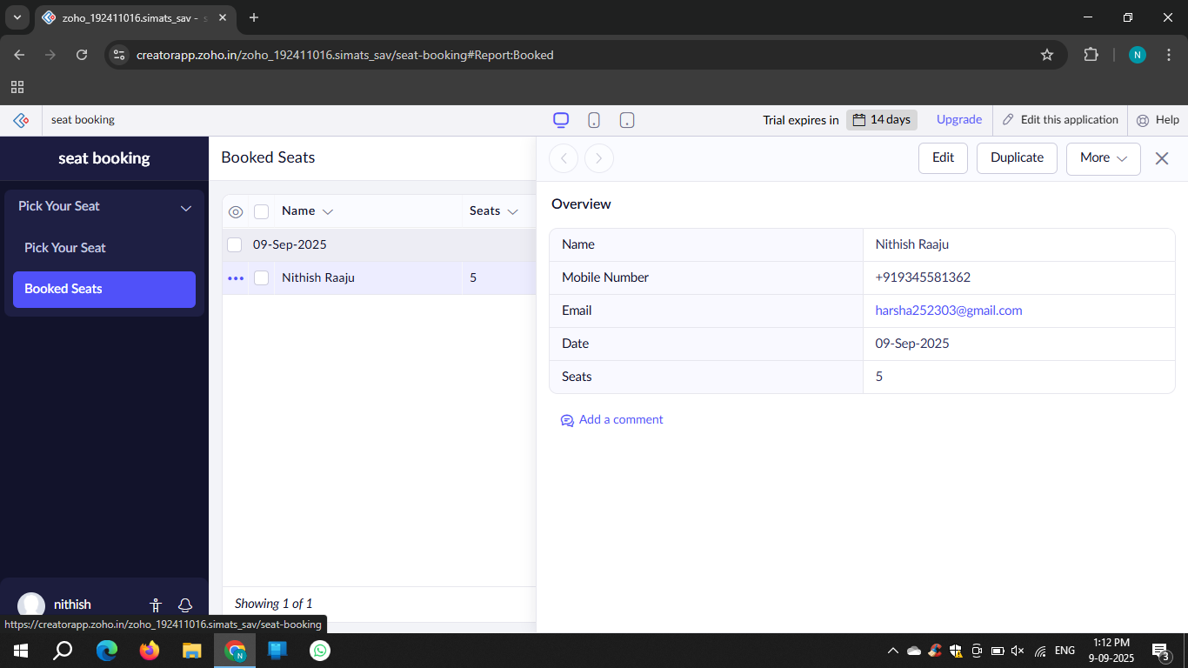

Result: The experiment was executed Successfully